Gaurav Gupta

2018UIC3093

Control System LAb Practical 1

Response Of Second Order System

Ans (i):

G =

130

----------------

s^2 + 15 s + 130

Continuous-time transfer function.

# Peak Time (tp):

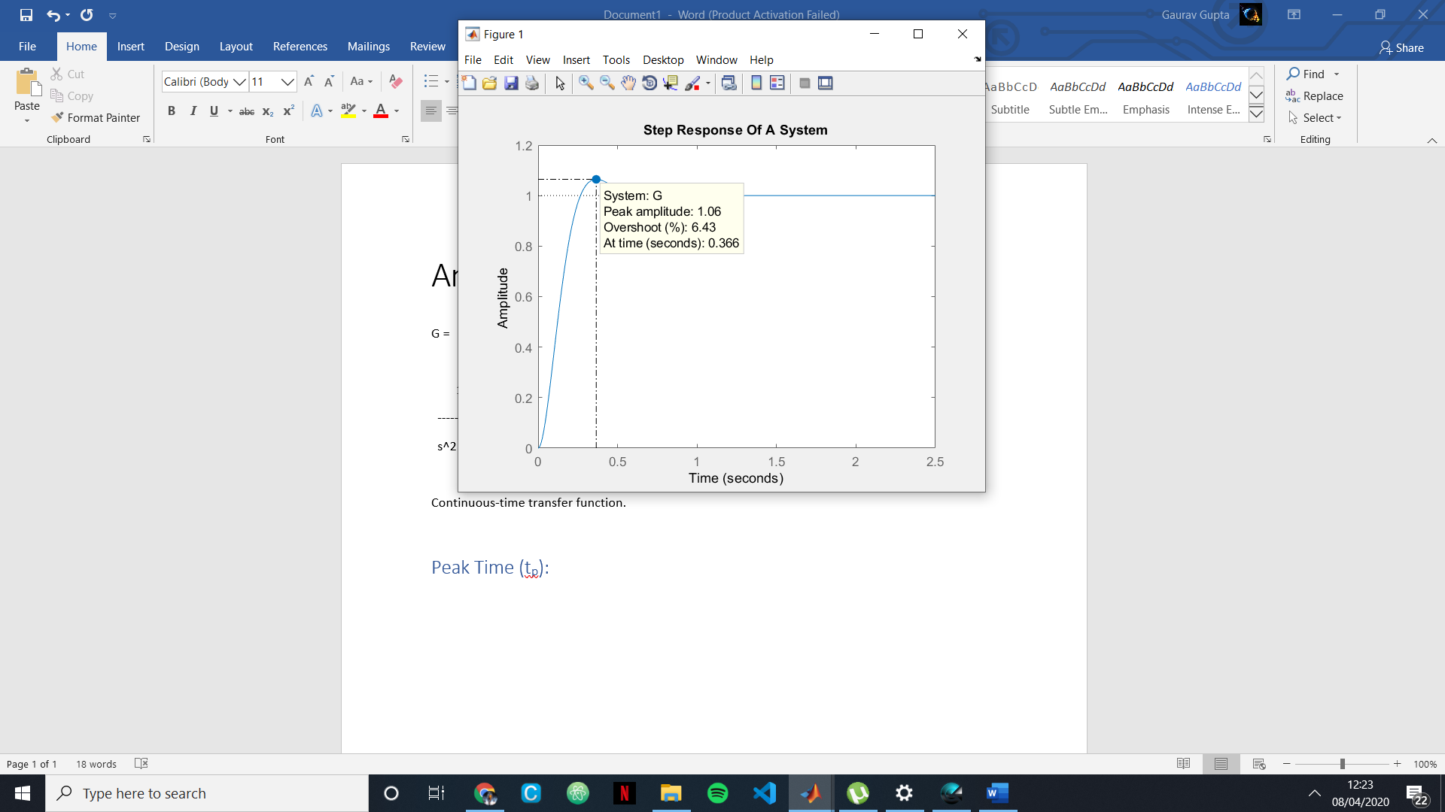

# Settling Time (ts):

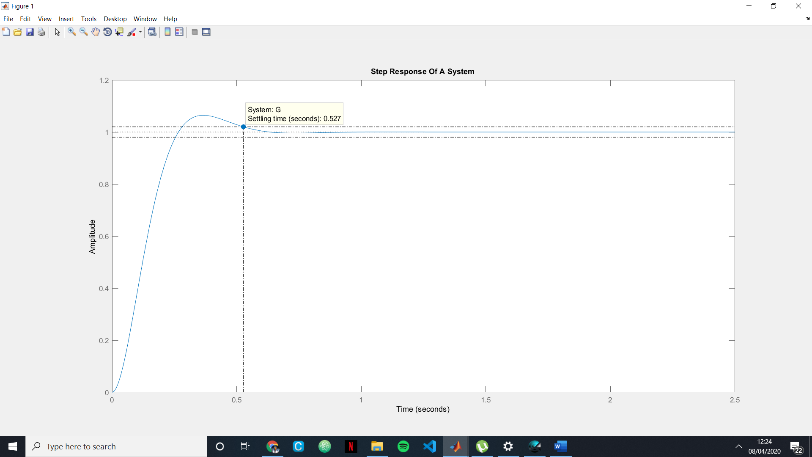

# Rise Time (tr):

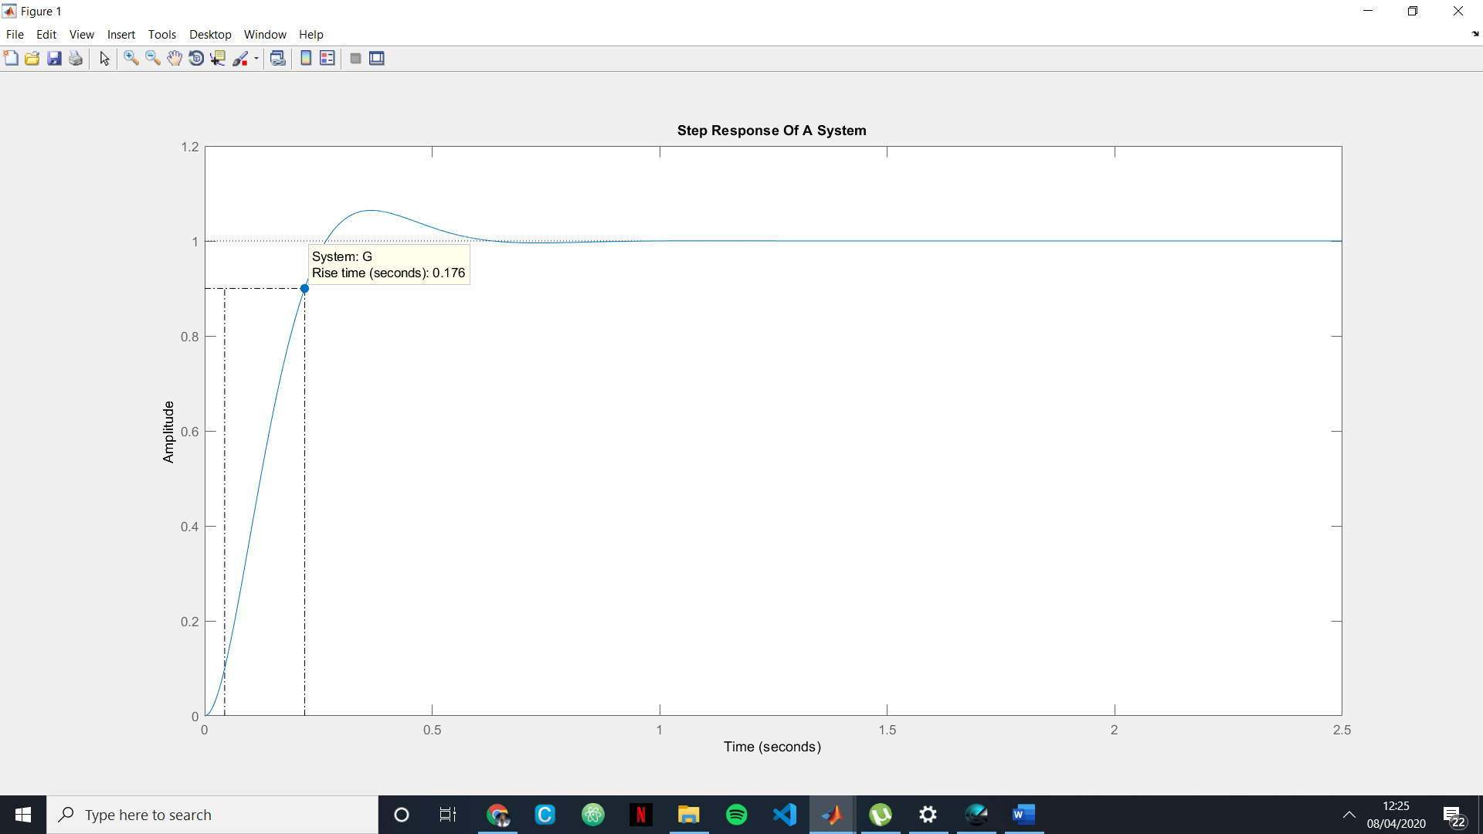

# Percentage Overshoot :

## Mp= 6%;

Ans (ii):

G =

0.045

-------------------------

s^2 + 0.025s + 0.045

Continuous-time transfer function.

# Peak Time (Tp):

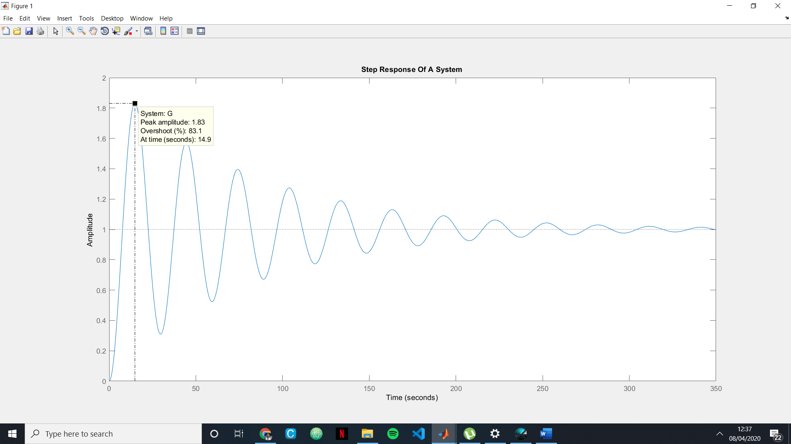

# Settling Time (ts):

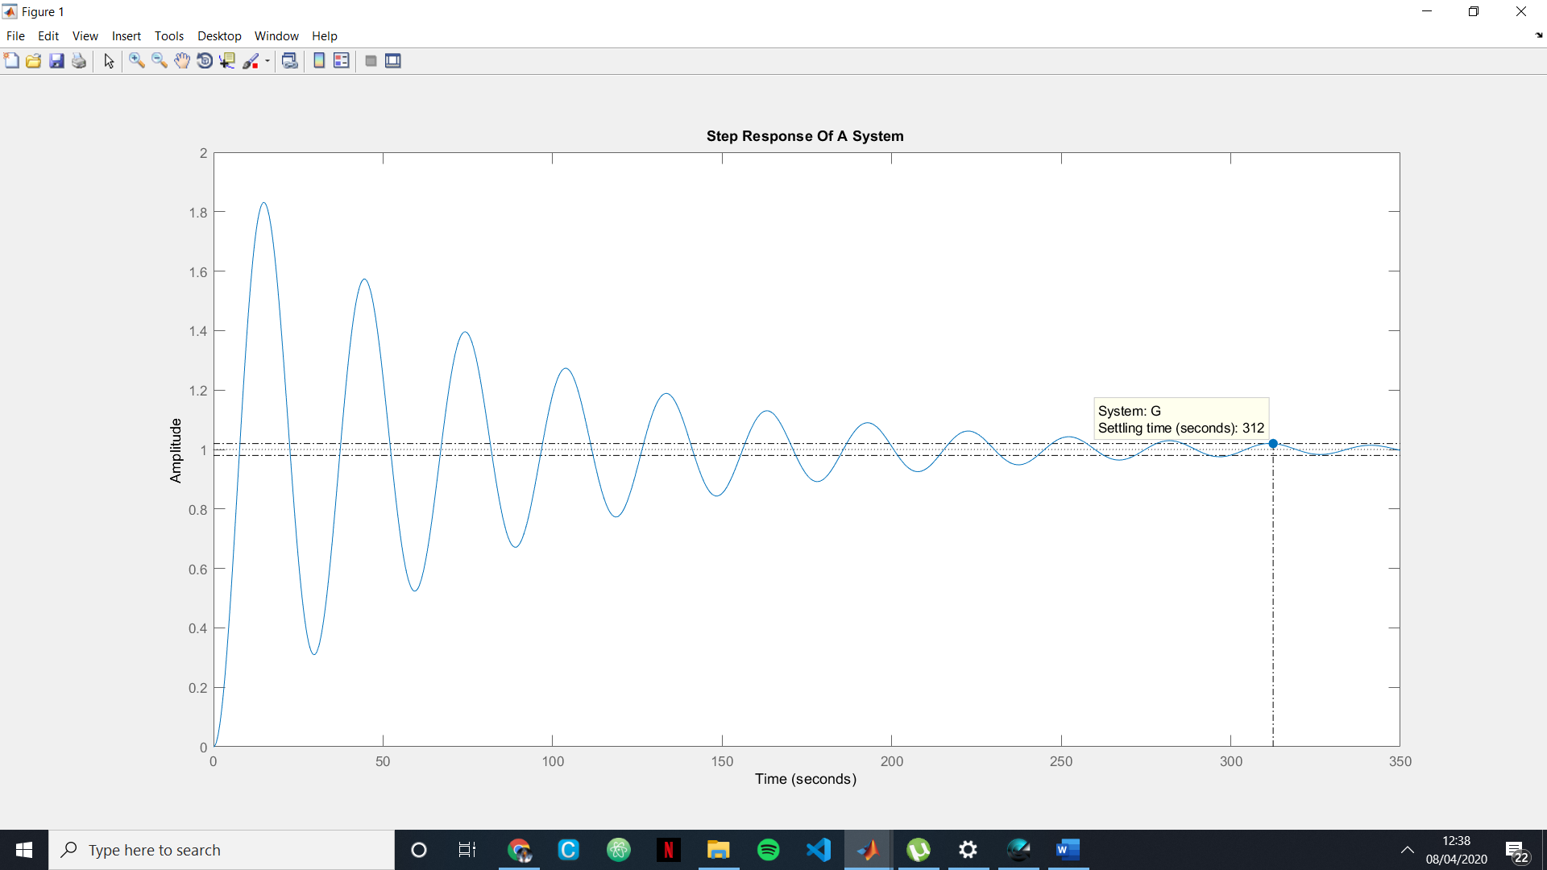

# Rise Time (tr):

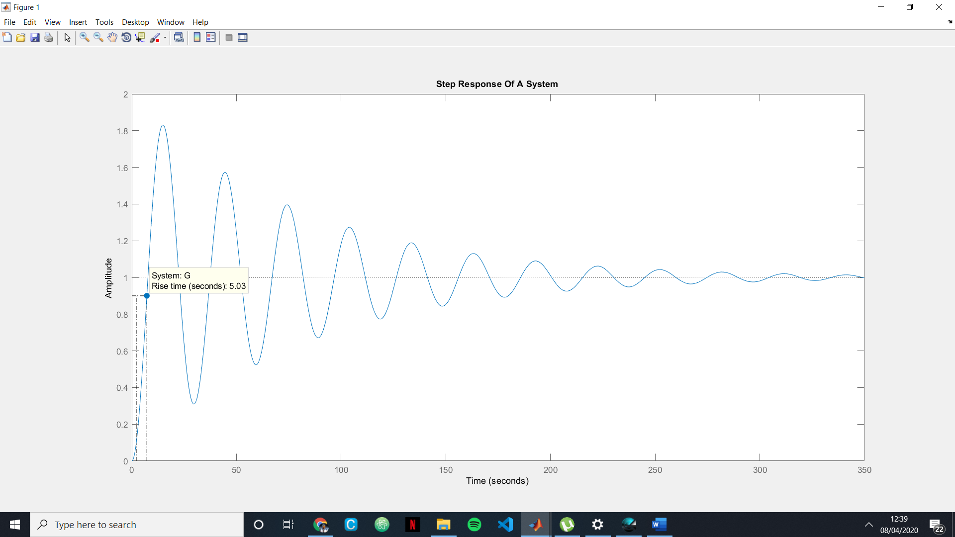

# Percentage Overshoot :

## Mp= 83%;

Ans (iii):

G =

108

-------------------

s^2 + 1.325*103 s + 108

Continuous-time transfer function.

# Peak Time (Tp):

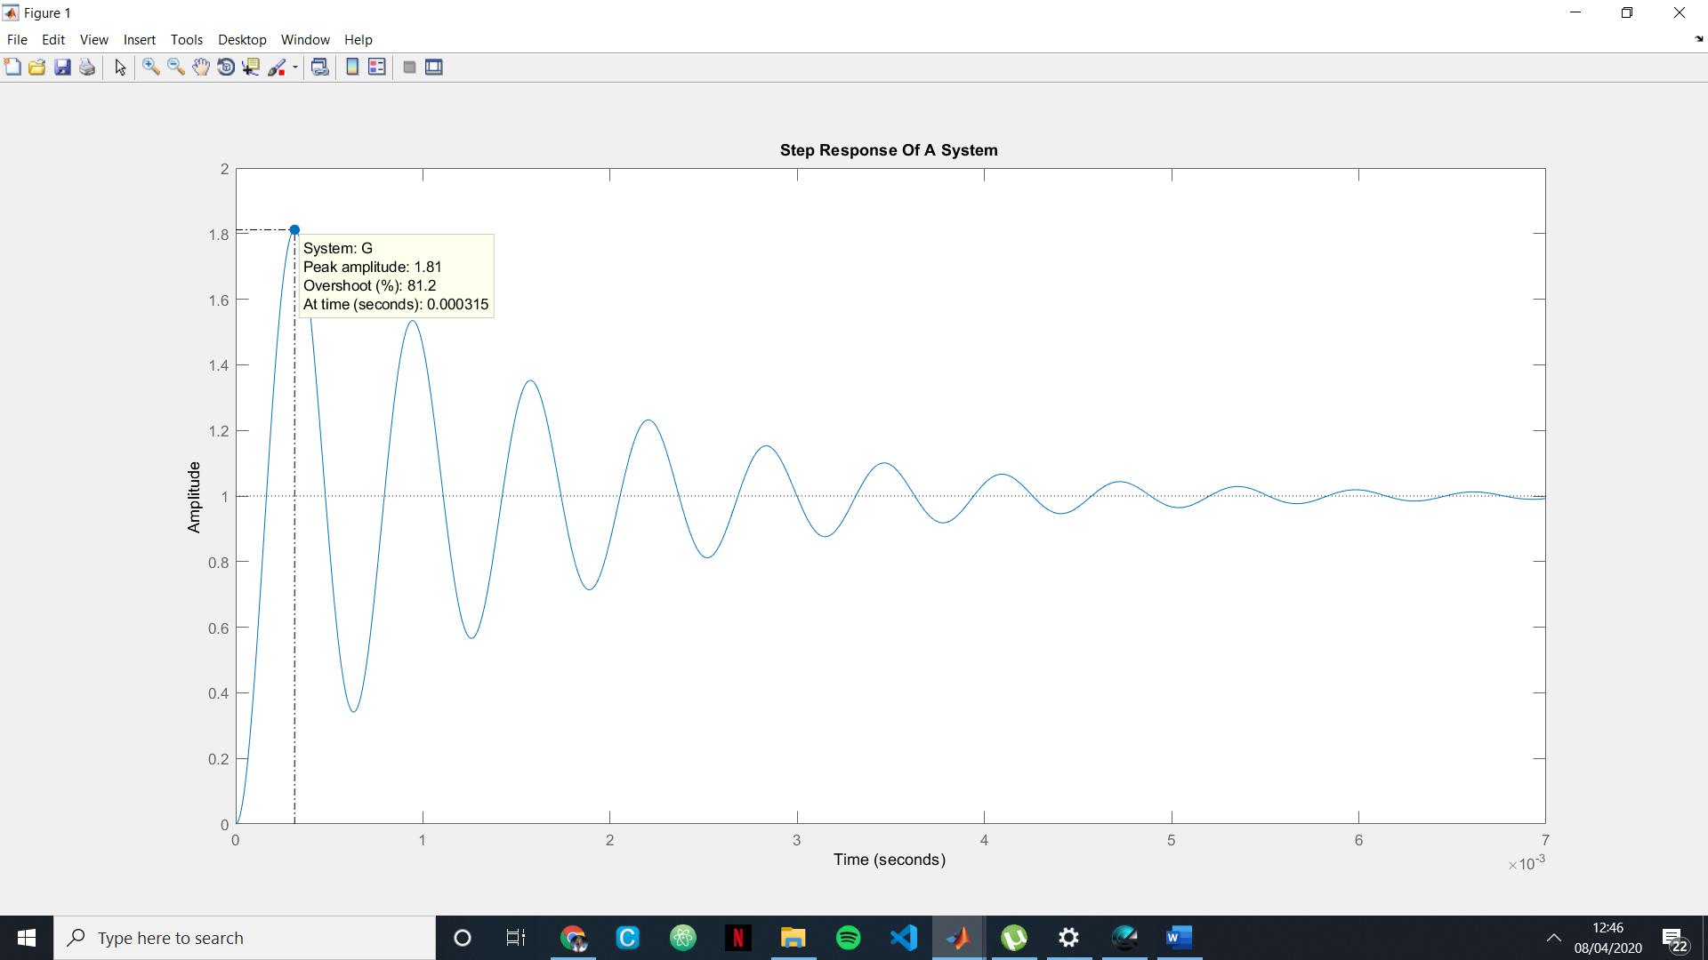

# Settling Time (ts):

# 

# Rise Time (tr):

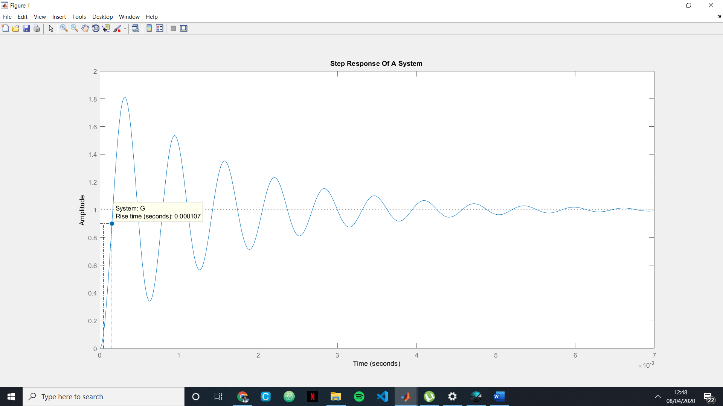Percentage Overshoot :

## Mp= 81.2%;